Dear Danielle,

Please see our findings below with regards to car travel and petal length:

**Car travel:** Our analysis (with 91% confidence) shows that the relationship between speed and distance is statistically significant meaning for every mile increase in speed we expect to travel 4.7501 miles. Please note, our model has margin of error of 8.047 miles in distance.

For instance, the predictive matrix below (first line) shows if the speed is five, the car would travel between 3.73 to 12.92 miles.

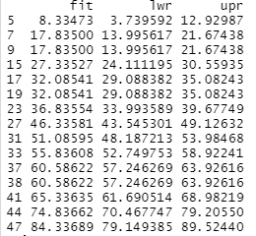

**Petal Length:** Our analysis (with 92% confidence) shows that the relationship between petal width and petal length is statistically significant meaning for every increase in width we expect the length to increase by 2.27. Please note, our model has margin of error of 0.48 in length.

For instance, the predictive matrix below (first line) shows if the width is one, the petal length would be between 1.32 to 1.63.

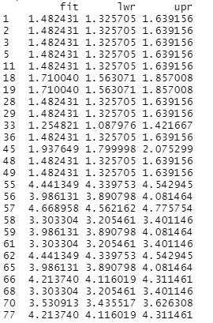

**Errors/Warning:** The only error I encountered was during the time I tried to use “lm” regression model. I was missing a character, so the “lm” function did not work. What I had to do was to simplify the column names to make it work.

**R:**  It was straight forward to install R and I didn’t face any problems. The tutorial was spot on and I will definitely recommend it to others.

I also learned the regression model and all the corresponding measurements (such as P- value) along with how to interpret those measurements.

I found R very user friendly and intuitive. Being able to see your codes, plots and data on the same page is plus. Also R library is very easy to access; you are able to see all functions with descriptions in one place without needing to go to the other websites.

Armin